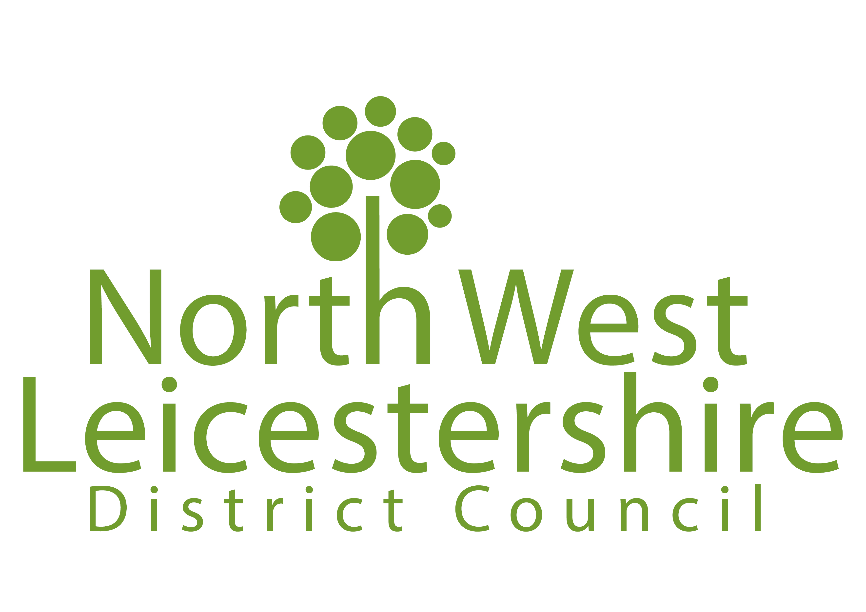
Ref:

(For official use only)
ASHBY DE LA ZOUCH NEIGHBOURHOOD PLAN REVIEW
Submission Consultation – Response Form

After assessing responses to the ‘Pre-Submission’ consultation, Ashby de la Zouch Town Council has now formally submitted the ‘Submission’ version of the Ashby de la Zouch Neighbourhood Plan Review to North West Leicestershire District Council. In accordance with Section 16 of the Neighbourhood Planning (General) Regulations 2012*, we are consulting on the Neighbourhood Plan for six weeks, from Monday 07 April to 11.59pm on Monday 19 May 2025.

The submission plan and supporting documents can be viewed at
https://www.nwleics.gov.uk/pages/ashby_neighbourhood_plan_review

Please complete this form and either email it to planning.policy@nwleicestershire.gov.uk or post it to Planning Policy, North West Leicestershire District Council, PO Box 11051
Coalville, LE67 0FW
We must receive responses must by 11.59pm on Monday 19 May 2025.

*Including amendment regulations; The Neighbourhood Planning (General) (Amendment) Regulations 2015 and The Neighbourhood Planning (General) and Development Management Procedure (Amendment) Regulations 2016.

PART A – Personal Details

If you are responding on behalf of yourself, or your own organisation, please fill in all the ‘Personal Details’ fields. If an agent is appointed, please complete only the Title, Name and Organisation boxes in the Personal Details column, but complete all the ‘Agent’s Details’ fields.

 | Personal Details | Agent’s Details (if applicable)
Title
First Name
Last Name
Job Title (where relevant)
Organisation (where relevant)
Address Line 1
Address Line 2
Address Line 3
Address Line 4
Postcode
Telephone
Email address

Do you wish to be notified of the Council’s decision on the Neighbourhood Plan proposal?

 | Yes |  | No

PART B – Your Representation
In the left column below, please state which part of the Neighbourhood Plan your representation relates to (for example which section, page or policy). In the right column, please submit your comments.
You can comment on as many different parts of the Neighbourhood Plan as you wish (please add more lines if required).

Section, page or Policy (please specify for each comment) | Comments

Declaration
I understand that all comments submitted will be considered in line with this consultation, and that my comments will be made publically available and may be identifiable to my name / organisation.
I acknowledge that I have read and accept the information and terms specified under the Data Protection and Freedom of Information Statement.

Signed:

Date:

DATA PROTECTION AND FREEDOM OF INFORMATION STATEMENT
The personal information you provide on this form will be processed in accordance with the requirements of the Data Protection Act 2018. It will be used only for the preparation of the Ashby de la Zouch Neighbourhood Plan Review as required by the Neighbourhood Planning (General) Regulations 2012*, save for requests of such information required by way of enactment. Your name, organisation and representations will be made publicly available when displaying and reporting the outcome of this statutory consultation stage and cannot be treated as confidential. Other details, including your address and signature, will be treated as confidential.
You should not include any personal information in your comments that you would not wish to be made publicly available.
Further information about the Council’s privacy policy and how we collect, store and use your personal data can be found here.
*Including amendment regulations; The Neighbourhood Planning (General) (Amendment) Regulations 2015 and The Neighbourhood Planning (General) and Development Management Procedure (Amendment) Regulations 2016.

Please send completed forms to planning.policy@nwleicestershire.gov.uk or
Planning Policy Team, NWLDC, PO Box 11051, Coalville, LE67 0FW

The deadline for responses is 11.59pm on Monday 19 May 2025.

