

ARRANGEMENTS FOR PUBLIC ACCESS TO MEETINGS

Members of the public may attend any public committee meeting either in person or online. A [calendar of upcoming committee meetings](https://minutes-1.nwleics.gov.uk/mgCalendarMonthView.aspx?GL=1&bcr=1) is available to view on the council website.

All committee meetings are held at Stenson House, London Road, Coalville. Dates and times will be published on each committee agenda. Details of each committee including dates, times and agendas can be found on the [committee pages](https://minutes-1.nwleics.gov.uk/ieDocHome.aspx?bcr=1) on the council website.

Attending a committee meeting in person

If you are arriving by car, [London Road car park](https://www.nwleics.gov.uk/pages/london_road_car_park) (LE67 3JB) is directly next to Stenson House and charges apply from 8am to 5pm.

Please arrive at least 15 minutes prior to the start of the meeting, you will be met by an officer who will show you to your seat and answer any questions you may have.

You do not have to stay for the full meeting, if you are attending for a particular item, you can leave once the item of interest to you has finished.

Committee meetings are streamed online and there is a possibility you will be seen on camera, therefore by attending the meeting you are giving your consent to being filmed and your image being used.

Viewing a committee meeting online

The committee meetings are live streamed using Microsoft Teams Town Hall.

You can access the link to view a committee live stream from the [council democracy page](https://www.nwleics.gov.uk/pages/council_and_democracy) which lists meetings taking place each week. You can also access the link alongside the agenda and report documents on the [committee pages](https://minutes-1.nwleics.gov.uk/ieDocHome.aspx?bcr=1).

If you are unable to watch the live stream, you will be able to watch the recording once it has been published the morning after the meeting. The recording can be found alongside the agenda and report documents on the [committee pages](https://minutes-1.nwleics.gov.uk/ieDocHome.aspx?bcr=1). Once you have selected the meeting you want to watch you can view the meeting by clicking on the link to the recording as shown below:

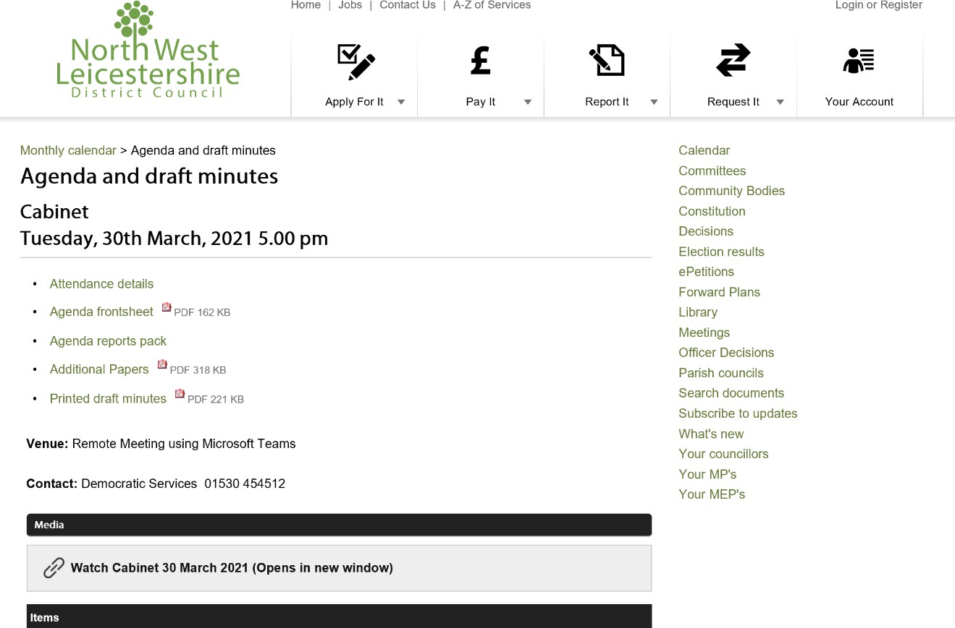

Please note:

* The links to access the livestream for each committee are added to the council website at least the day before the scheduled committee meeting.
* The livestream will not start before the start time on the agenda.
* Microsoft do not currently support access to Town Hall by mobile devices, you can only view the meeting from a desktop device.
* You will not be able to view the meeting on Firefox or Safari web browsers; please download Microsoft Edge to your device.
* You will only be able to view the meeting. There will be no opportunity to ask questions or take part in the debate.